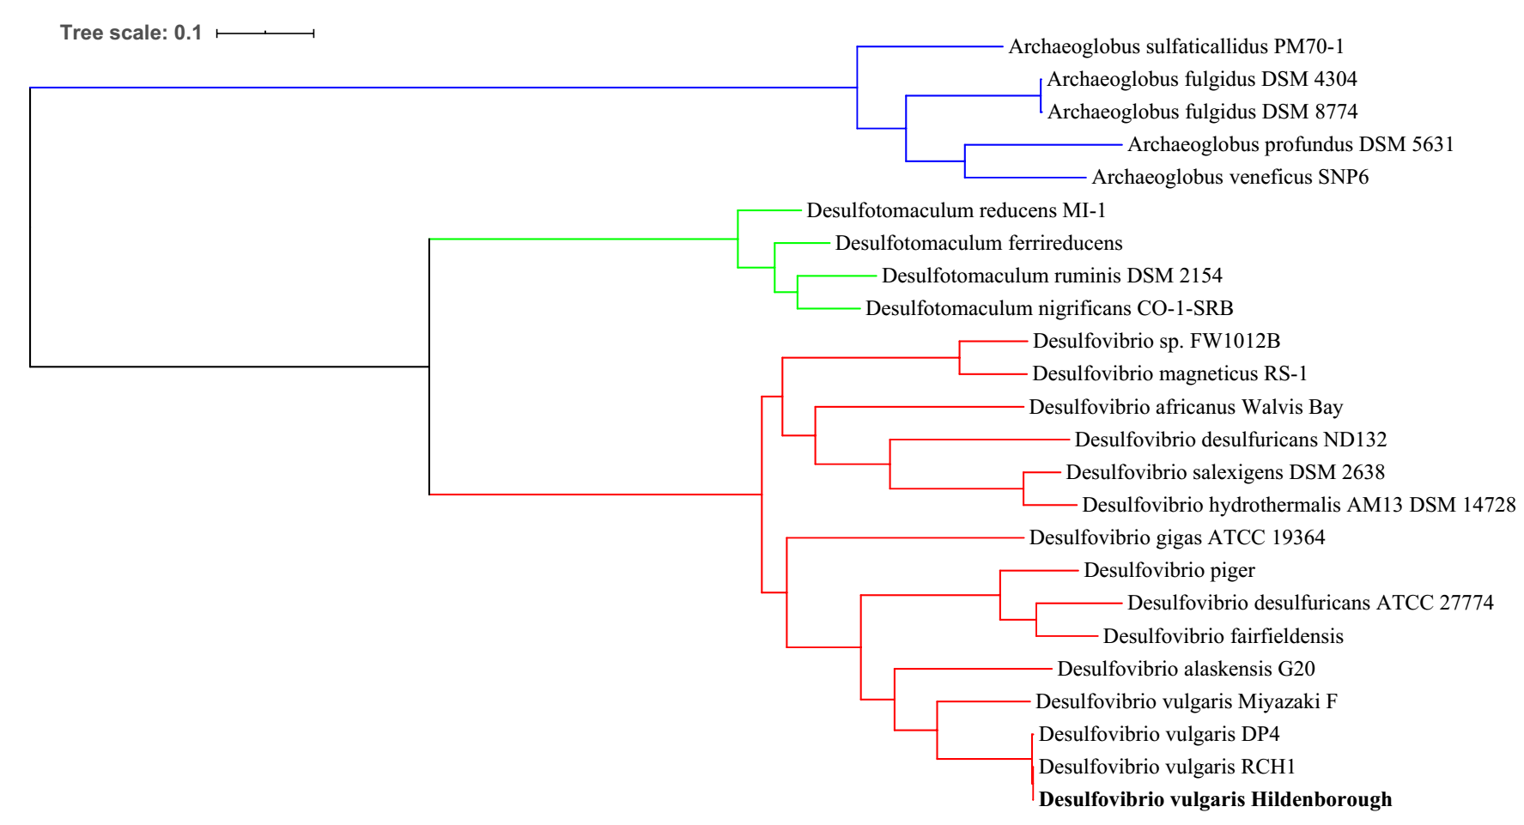

**Figure S1**. The 24 SRP genomes used in this study and their genetic relationships illustrated by a phylogenetic tree. The phylogenetic tree was constructed via the FastTree tool version 2.1.10 (M. N. Price et al., 2010) using a set of 49 core, universal genes defined by COG (Clusters of Orthologous Groups) gene families.

The COGs domains used in the estimate of relatedness include: COG0012, COG0013, COG0016, COG0018, COG0030, COG0041, COG0046, COG0048, COG0049, COG0051, COG0052, COG0072, COG0080, COG0081, COG0082, COG0086, COG0087, COG0088, COG0089, COG0090, COG0091, COG0092, COG0093, COG0094, COG0096, COG0097, COG0098, COG0099, COG0100, COG0102, COG0103, COG0105, COG0126, COG0127, COG0130, COG0150, COG0151, COG0164, COG0172, COG0185, COG0186, COG0215, COG0244, COG0256, COG0343, COG0504, COG0519, COG0532, COG0533.

|  |
| --- |
| a) |
| b) |
| c) |
| d) |
| e) |
| f) |

**Figure S2**. Core genome and pan-genome development plot projections for a) and b) *Archaeoglobus*, c) and d) *Desulfovibrio*, and e) and f) *Desulfotomaculum*. For Core genome development plot extrapolation: the red curve shows the fitted exponential decay function, and the blue and green curves indicate the upper and lower boundary of the 95% confidence interval.

**a)**

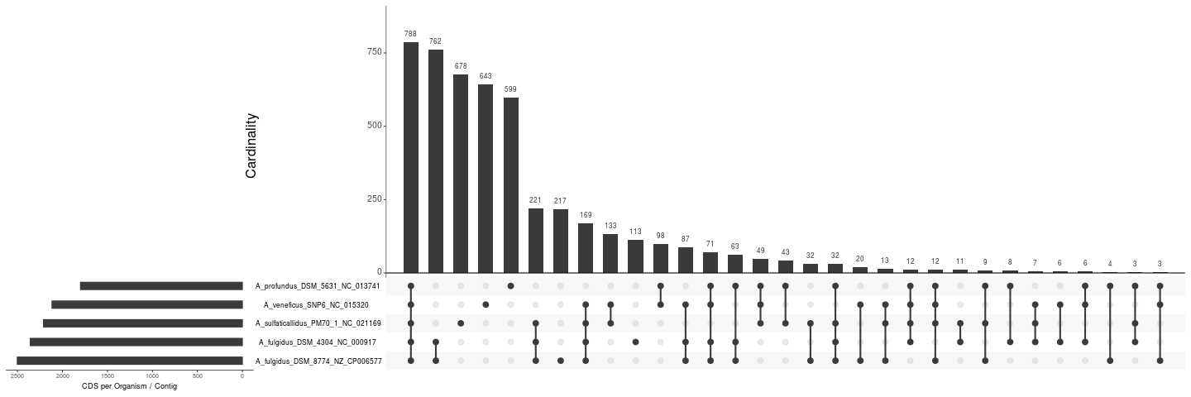

**b)**

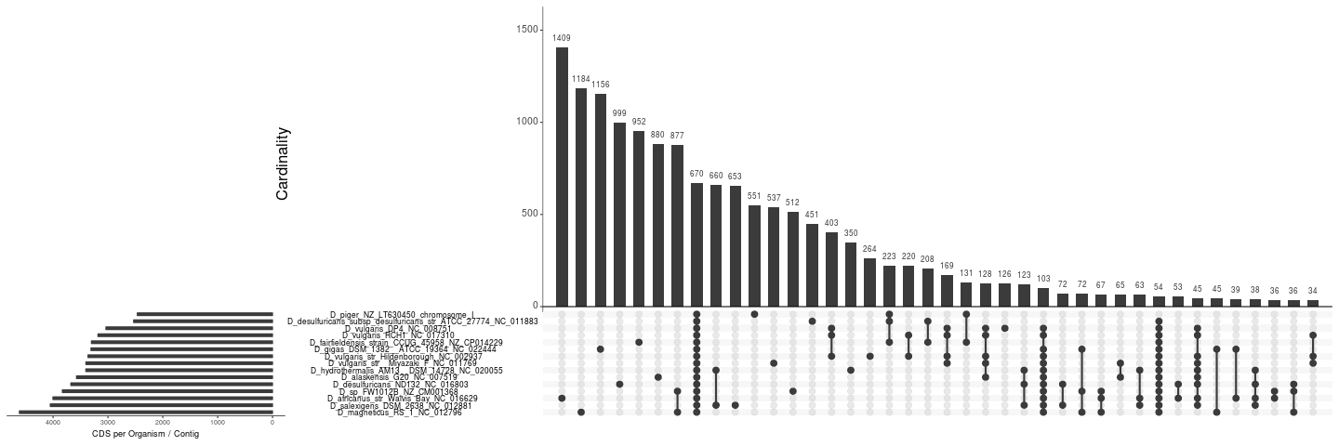

**c)**

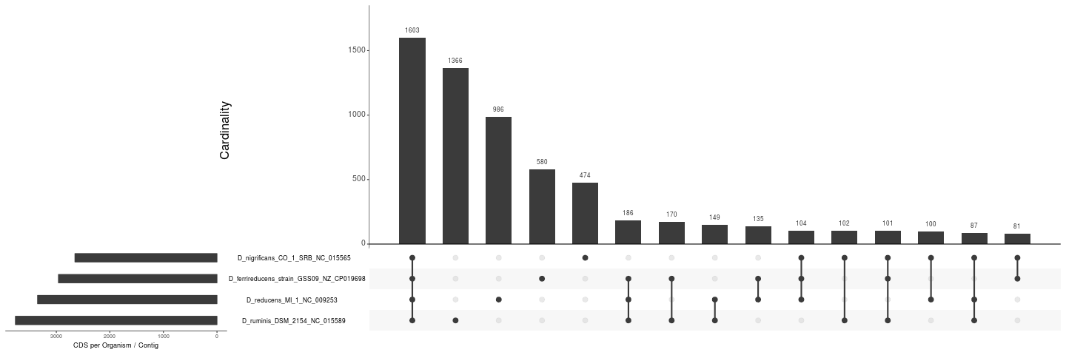

**Figure S3**. UpSet plot of a) *Archaeoglobus*, b) *Desulfovibrio*, and c) *Desulfotomaculum*.